Instant-Quote.co – Features & Functions – Apr 2018
Contents
Instant-Quote.co – Features & Functions – Apr 2018 1
What is Instant-quote.co? 4
High level features 4
About Quotations 4
The Quotation page 4
Restricting what you quote for 5
Double bookings 6
Integration with WordPress based websites 6
Quotation page plugin 6
Datasheet plugin 6
Advantages of using the Quotation page 6
Pricing Model 7
Global Price Model 7
Asset Prices 8
Packages & Package pricing 9
Configuring an Asset Package 10
Packages in the Quotation page 10
Sharing with other businesses 10
Communicating with the customer 12
Customer’s My Booking page 14
Reviews 14
Online payments 16
Administration 16
Overview of administration 17
Supposition: 17
Administration layout 17
Navigation Tab pages 19
Bookings Tab 19
Quotation Tab 22
Finance Tab 24
Website Activity Tab 25
Weekly Statistics 26
Configuration Tab 26
Google Calendar Integration 27
Prices and Packages tab 28
Settings playground 28
Marketing Tab 28
My Account Tab 29
The Card Payments Tab 29
Directories Tab 29
Agency Tab 30
System Logs Tab 30
Online Booking 30
Abandoned bookings 31
System Pricing 31
Agency Pays 31
Limitations 31
Monthly Costs 31
Free Plan 31
Limitations 31
Includes 31
Monthly Costs 31
Low Plan 31
Limitations 31
Includes 32
Monthly Costs 32
Medium Plan 32
Limitations 32
Includes 32
Monthly Costs 32
Professional Plan 32
Limitations 32
Includes 32
Monthly Costs 32
Professional Plus Plan 32
Limitations 32
Includes 33
Monthly Costs 33
Directory Only 33
Limitations 33
Includes 33
Monthly Costs 33
Agency Plans 33
Quotations & billing 33

Figure 1- The Quotation Page 5
Figure 2- WordPress Plugin search 6
Figure 3 - Editing a price list 8
Figure 4- Editing a Package 9
Figure 5- Agency Quotation Page showing shared assets 11
Figure 6 - The Information Tab 12
Figure 7- The My Booking page - available to the customer 14
Figure 8- Invitation to review email 15
Figure 9- A review 16
Figure 10 - The Dashboard 18
Figure 11- Notifications 18
Figure 12- Adding journeys to a new booking 19
Figure 13 - Editing the booking timetable 20
Figure 14 - Bookings charts 22
Figure 15 - Quotation Charts 23
Figure 16 - Website visitor Locations 27
Figure 17- Launching navigation from Google maps on a mobile phone 28

What is Instant-quote.co?
Instant-quote.co is a complete software ecosystem that enables customers to automatically send quotations based on the organisation’s business model, collect customer payments and manage their business.

High level features
The high-level features are:
- Automatic quotations
- Online booking
- Customer’s My-booking page
- Automatic payment reminders
- Online card payment
- Automatic Review request & publication
- Customisable documents
- Enhanced online presence
- Micro Website
- Jobs access for staff
- Low cost
- Date backed up

About Quotations
The first step in developing and maintaining your business is a strong internet presence, hopefully with a well thought out marketing strategy to engage the customer with your products. It’s no longer enough to engage in fairs and exhibitions because the Internet is with us and customers are now demanding instantaneous results.
It’s competitive out there and it’s not comfortable for those of us with an ‘old school approach’ of leaflet drops, yellow pages and wedding fairs. The order of the day is a continuous stream of fresh content on the Internet including Facebook posts, relevant blogs with new photographs and reviews as a minimum to start rising up the search engine rankings.
The issue comes when a customer finally reaches your well-dressed website or Facebook page. They’ll love your pictures and your Customer feedback but they need to know how much it’s all going to cost, not tomorrow or the day after - but now.
A contact form is no longer good enough, the turnaround time just doesn’t cut it for today’s consumer which is why we have created the IQ Quotation Page.

The Quotation page
The quotation page is integrated into the business’ website and Facebook page, so customers are not lost to the site. It’s an incredibly powerful tool that will get your site visitor engaged with your business and can be styled to match the look of your site.
When the page is loaded, the visitor selects the date of the event & the location. The quotation page then displays the items that are available for that date and are in range (as the crow flies) of the event location. (Note that quotations are based on road mileage.)
The customer then enters their email address and any other locations and selects the items they want a quote for. Job done! Within a quarter of a second an email is on its way to the visitor with prices based on your business model.
The locations being quoted for are displayed on a google map along with the route to be taken.
There is more to the quotation page than that. The visitor can select the information button for any item and see additional photographs, videos, general pricing information, descriptive text and, if the item has been reviewed, a summary of reviews.
The quotation page has two levels of customisation, firstly in the system administration interface where the fields of information can be customised (labels changed, made obligatory, hidden) and on the site itself where your web developer (or our support team) can make changes to most aspects of the quotation page to optimise it for the site.
I addition to displaying individual items the quotation page can also display groups of items as a package. Packages can also include groups of extras. The content of a package is displayed on the information tab.
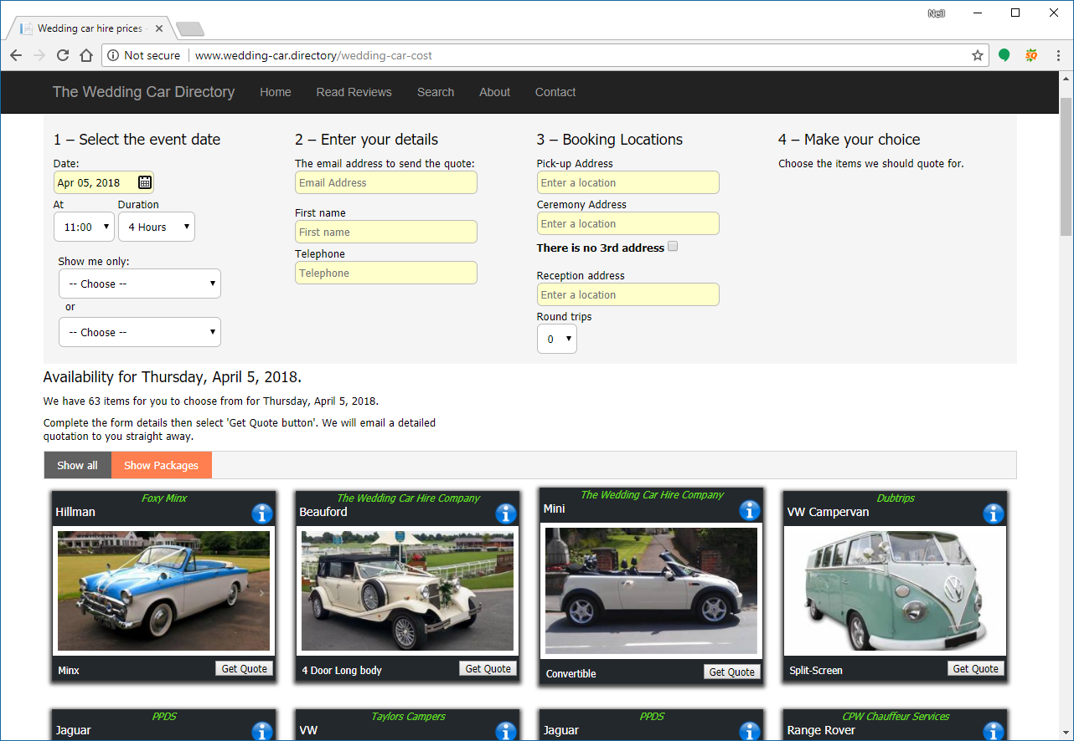
Figure 1- The Quotation Page

Restricting what you quote for
In addition to your items only being displayed on the quote page where they are in approximate range of the start location of the event, you can also restrict what you quote for based on the following:
- The distance by road you are prepared to travel to an event.
- The distance you are prepared to travel during an event.
- The overall distance covered over the entire event including returning to base.
- You can setup a postcode blacklist for places you are not prepared to go.
- Mileages can be overridden for bookings and quotations when using the admin interface to quote or make a booking.

Double bookings
The system makes it very difficult to suffer from double bookings as both the quotation and booking sides are aware of the availability of your items.

Integration with WordPress based websites
Our recommended platform for websites is WordPress. It’s relatively easy to use and there are a wide range of templates out there to define the look of your site.
Furthermore, we have developed plugins for WordPress that make installation of the quotation page easy for a technically minded user or web developer.
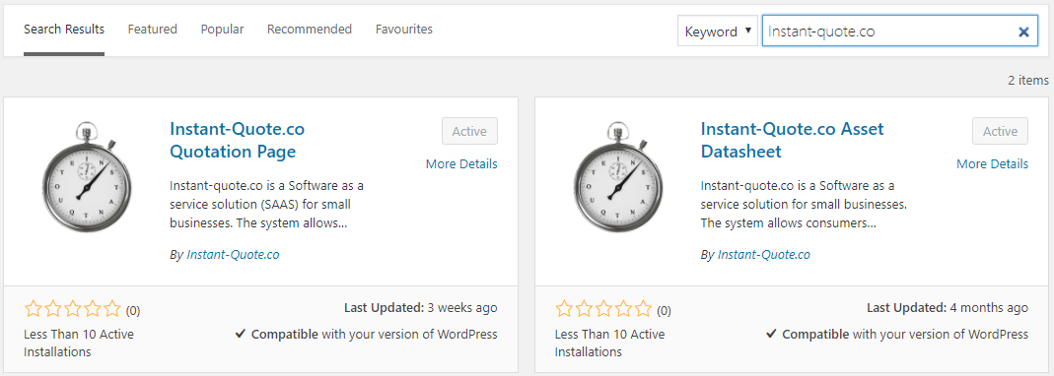
Figure 2- WordPress Plugin search

Quotation page plugin
The IQ Quotation page embeds the quotation page in your site that displays your Assets that are available for a date and enables customers to get their quote.

Datasheet plugin
The IQ datasheet enables you to display a webpage on your site that is populated from our servers with your photos, price guide, review summary and product video – or any combination of those items.

Advantages of using the Quotation page
There are many advantages to using the quotation page:
- You only sell what you have available
- You save time by automating the process
- You don’t receive calls for booked items
- Visitors can see pictures and videos
- Visitors can read descriptive text
- It’s mobile friendly
- It’s customisable
- Visitors remain on your site
Both plugins are very easy to implement and full instructions are provided with the plugins. The pages that are created can be styled according to your site design.
You can read more at https://www.instant-quote.co/WordPress.aspx.

Pricing Model
All of this magic doesn’t happen on its own - the application is data-driven and runs on your data.
The most complex area of setting up the system is pricing, but as it’s your pricing you should be familiar with the numbers.
There are, however, some aspects that are configurable that you may not have considered - in fact you may not even have a structured pricing model.
The system encourages you to think about your pricing and optimize it for supply and demand. In a seasonal business demand should be higher in the busy season and hence prices are also higher.
You can of course just charge the same price irrespective of time, distance, season etc. that’s your prerogative. Conversely you can micromanage every moment of the booking.

Global Price Model
The global settings layout your company’s overall policy and if you have more than one website, you can define a different pricing model for each site. The model describes what you charge and how you charge for it.
The settings are:
- Do you Charge per hour?
- Minimum booking time.
- Threshold for applying additional time charges.
- Do you charge for travelling to an event?
- Do you charge per mile?
- The threshold for applying a mileage charge.
- Do you charge a surcharge for round trips?
- How many round trips are included without charge?
- Do you charge a different rate per hour travelling to the event to travel during the event?
- Some events require setup and pack-up time is this a different rate?
- If you are off duty during a booking, do you charge a different rate for this?
- Do you charge for cleaning and stowage after the event?
- If you enforce a Gratuity charge, what is the percentage?
- Do you charge a different rate for public holidays?

Asset Prices
The prices for your individual items build on the on top of your pricing model. Each item has an individual price list and if you have multiple websites, price lists can be different for each site.
Price lists are defined for a date range so prices can be configured for years into the future without disturbing your existing price structure.
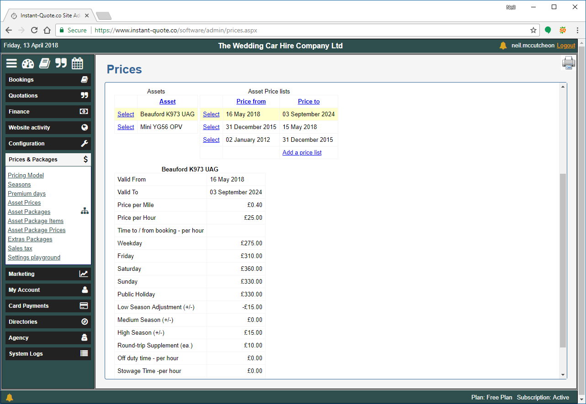
Figure 3 - Editing a price list
The price list settings are:
- Web site to which it applies.
- Adjustment for Market vertical (if used).
- Date valid from.
- Date valid to.
- Price per mile.
- Price per hour.
- Travel to / from event price per hour (if used).
- Weekday price (Mon- Thu).
- Friday price.
- Saturday price.
- Sunday price.
- Public holiday price.
- Adjustment for low / medium / high seasons.
- Off duty price / hour (if used).
- Stowage time / hour (if used).
Additionally, you can set up special dates, for example Valentine’s day, which may fall on a weekday in February and could be in the low season. For many businesses this would be a key date that you may want to charge more for.

Packages & Package pricing
Packages enable you to group Assets together, furthermore a user can add one or more packages of extras.
- Packages combine one or more assets with zero or more bundles of extras.
- Packages can be configured to include time and or distance in the price.
- When presented through an Agency, your bundled extras are still included.
- Packages can be syndicated through Agency sites in the same way as Assets.
- Packages use a price list similar to an Asset.
- Different groups of Extras can be used for different months of the year giving you a seasonal offer.
- When presented through an Agency you are more likely to obtain multi Asset sales when a customer requires more than once asset.
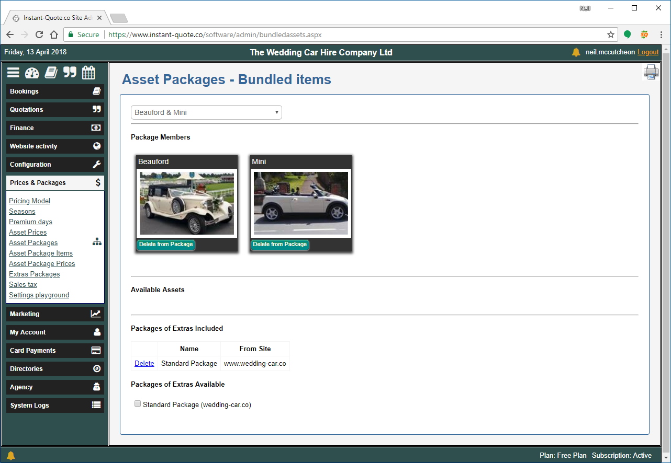
Figure 4- Editing a Package

Configuring an Asset Package
Once you have created your assets, go to Prices and Packages | Asset Packages, the system will automatically create a blank package.
- Select the edit button and rename the package – but keep it short!
- Work your way through the form completing the settings you desire and upload a representative photograph (in Landscape format).
- Navigate to package items.
- You will see the Assets you have available for the package. Select Add to Package to include the Asset in the package.
- If you have Packages of Extras they will also appear on this form. Select the check box to add a group of Extras to the package.
If you need to create a Package of Extras, first create your extras under Configuration |Extras then create a package of extras under Prices & Packages | Extras Packages.
- Create a price list under Asset Package Prices.
- Finally, once the configuration is complete, return to Prices and Packages | Asset Packages and un-hide the Asset Package. The package is now live & ready to be syndicated to any agencies you work with.
We recommend using the settings playground under Prices & Packages to check all your pricing is in order.

Packages in the Quotation page
Packages appear in the quotation page in the same way as assets do. Customers can view details of the package by loading the datasheet from the information button displayed on each item in the quotation page.
Notes
Asset packages work in conjunction with your pricing model settings but adds the concept of bundled time and distance.
When pricing is calculated, the additional cost per hour and the additional cost per mile figures for individual Asset is used for when the quotation is for more than the bundled time or distance.

Sharing with other businesses
The system enables you to share your items with other related businesses the use the system. Your item appear on the other business’ quotation page and quotes can be issued from there in the same way as your own site. Availability and pricing works in just the same way except the booking is placed on the other businesses account.
That business can then place the booking on to your own account and charge a commission or fee. We call this syndication.
Syndication can be used to place your items on a supported Agency site or with another local business.
Supported agencies include:
- The Wedding Car Hire People –
https://www.theweddingcarhirepeople.co.uk/
- The Yorkshire Wedding Car Company - https://www.theyorkshireweddingcarcompany.co.uk/
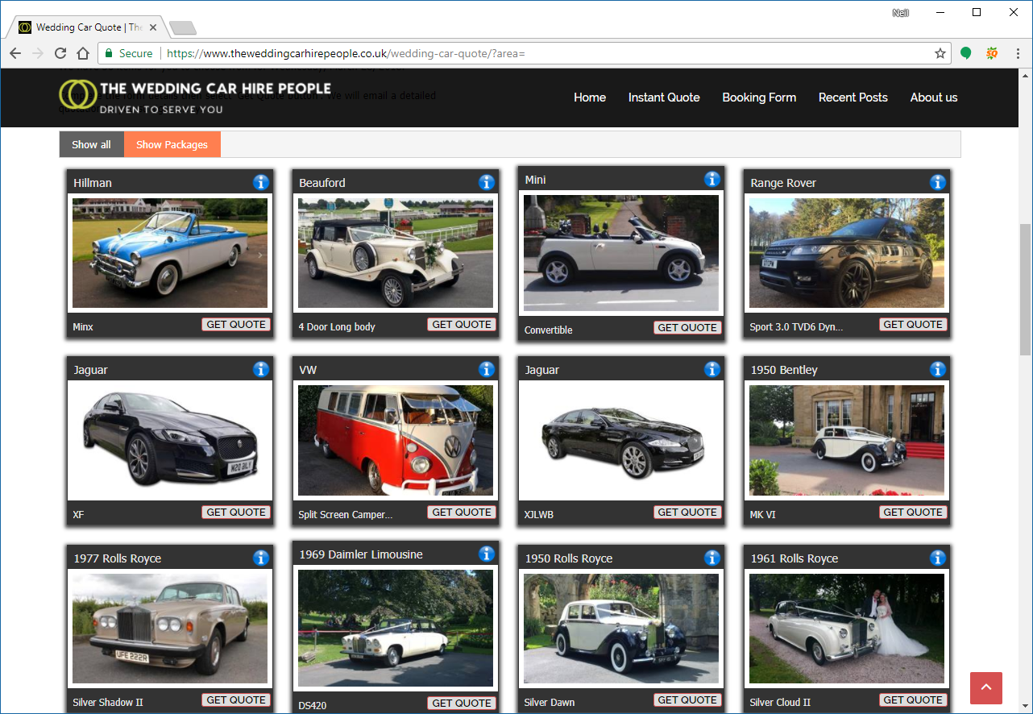
Figure 5- Agency Quotation Page showing shared assets
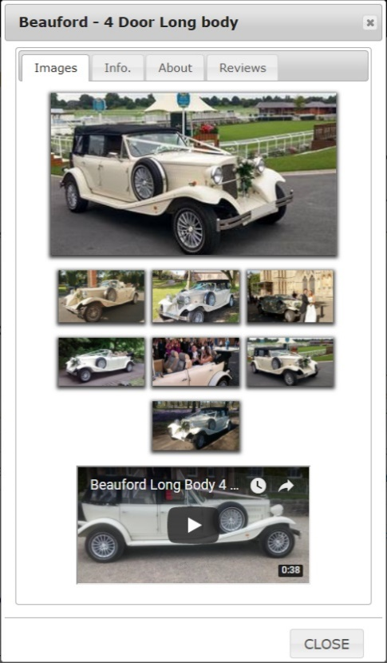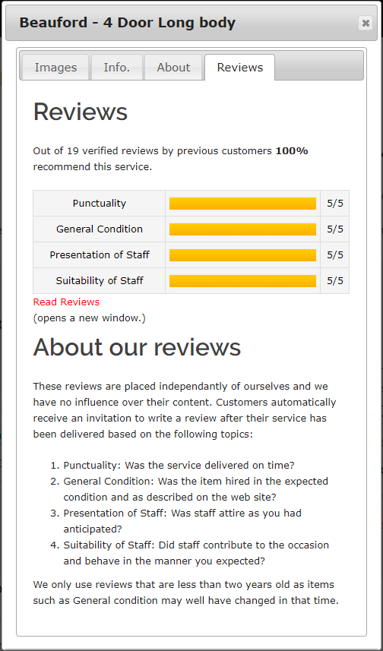
Figure 6 - The Information Tab

Communicating with the customer
Apart from the automated quotation email, the system can be used to send a number of emails:
Where possible, each of these emails are created with the document template editor and defaults are provided. The emails are personalised.
You can configure when the follow up email is sent to suit your own purposes, for example within a couple of days of sending a quote or 6 months before the event date.
The payment reminder is configured to be despatched a day or two before the balance is due to be paid for a booking and includes the balance due, the due date and payment instructions.
You can configure the system to use your own email server or use the email service that we subscribe to.
All emails go ‘from’ your own business except invitations to review that go from the system email address as they are intended to be independent.
In addition to these emails, you have access to a list of all the details we have for visitors you have sent a quotation to. You can also see who has not booked for the upcoming period and contact them if you have a date free.

Customer’s My Booking page
Every booking generates a my-booking page for the customer. This is an important feature that shares the details you have processed for a customer’s booking with the customer.
The page displays the timetable for the event, their payments to date and the list of extras they have booked.
We find this is a popular feature with customers and allays their fears pertaining to errors in the booking.
Furthermore, they can pay online after checking the itinerary.
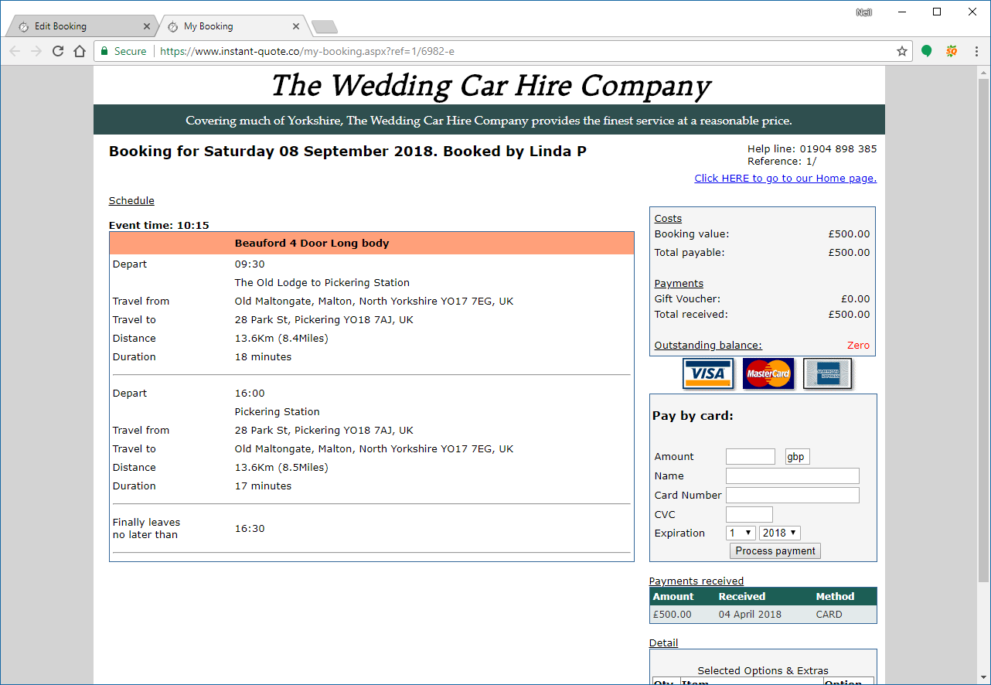
Figure 7- The My Booking page - available to the customer

Reviews
We all want testimonials for our websites and some customers are kind enough to write in and provide one - and some businesses just make them up.
Having independent review is a powerful marketing tool and the system makes it easy for you.
After a booking, we generate an invitation to review, this can be seen in the Administration interface under Marketing / Manage invitations to review.
If there has been a crisis, you may not want the Invitation to go out, so you can cancel it and it will not be sent. Otherwise the invitation will be sent two weeks after the event.
The email sent to the customer is personalised and asks them to write a short review - and many people do.
If the customer wrote a review, you will be notified that you have a review to approve. You can accept the review or publish it and comment on the review.
If you feel the review is unjust you can delete the review.
Reviews are published on the Instant-quopte.co web site and other syndicated destinations. A summary of reviews is visible on the information tab on the quotation page with a link to the full review.
Reviews are marked up in such a way that search engines such as Google understand the reviews and they perform very well in search results.
The key thing is that independent reviews are believed whereas testimonials have no provenance and may not be trusted by the consumer.
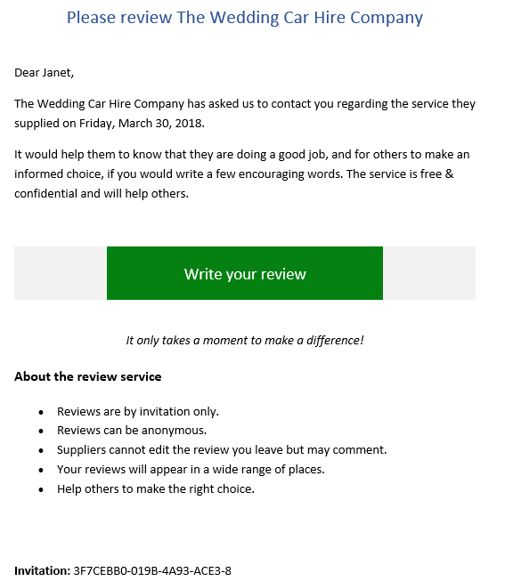
Figure 8- Invitation to review email
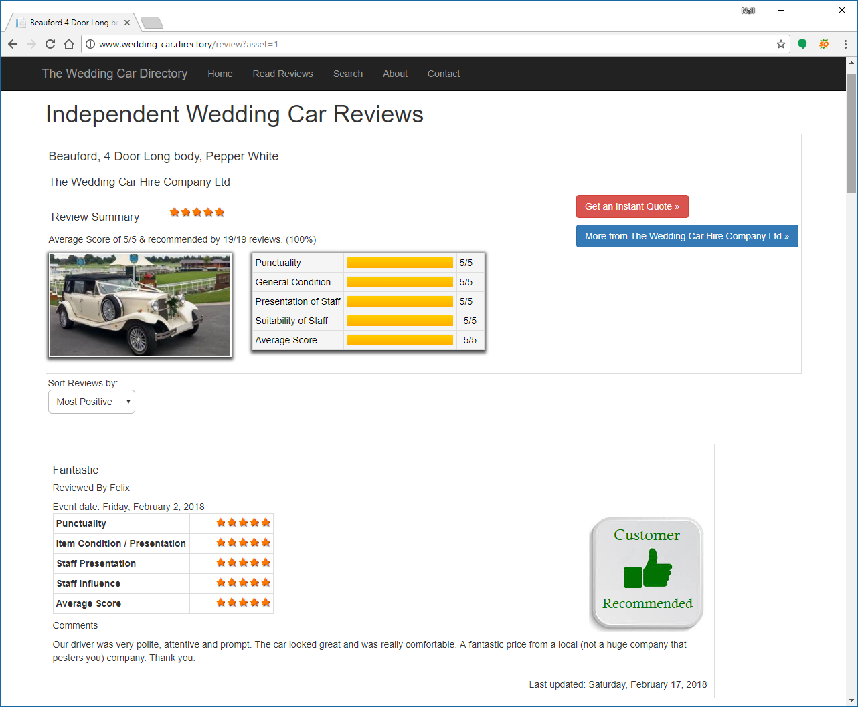
Figure 9- A review

Online payments
Collection of payments by the system is a key feature. Apart from collecting the customers money and transferring it directly to your bank in a timely fashion, using the card payment system applies the payment to the customer’s booking, and updates the administration system payments due and the financial statement.
Most card services providers insist on a contract and charge a monthly fee and to process cards – whether you take a payment or not. The system does not charge a subscription for processing cards and the transaction fee for cards issued in Europe is 1.4% + 70p.
If you use the system’s card processing, you will be able to accept VISA, Mastercard & American Express. We do not handle your money and the system is PCI compliant.

Administration
Sending quotes and collecting money is only part of the system, that’s because it’s only part of your business. The administration pages provide pages that enable you to not only operate your business, but see how it’s performing, share booking information with staff and study graphs of performance and finance.

Overview of administration

Supposition:
Relatively speaking, many business owners run their businesses on ‘gut feel’ and experience and not the data. In terms of business management, the business is running them as they can be reactive rather than proactive.
You might start by asking yourself:
- How many quotes did we send out in January?
- How does that compare to last year?
- What proportion of those were converted?
- What’s your average sale?
- How far in advance are people booking?
- What money is due in and when?
- Where are your website visitors coming from?
- What exactly is your pricing model?
- Do you charge extra for bank holidays or Valentine’s day?
- How long does it take you to respond to a quote?
- Once your items are booked for the second Saturday in August, how many calls do you get for that date?
- How do you go about getting reviews?
- Etc, etc.
To make informed decisions, this is the sort of information the business owner should have to hand when they come to review their business performance and tactical planning.

Administration layout
The system is laid out in to logical blocks in a vertical menu with ‘hot keys’ at the top of the page.
The divisions are:
- Bookings
- Quotations
- Finance
- Website Activity
- Configuration
- Prices & packages
- My Account
- Card Payments
- Directories
- Agency
- System Logs
When any of the top-level headings are selected, a sub menu of related items is displayed.
At the top of the vertical menu are hot keys for:
- Dashboard
- New Booking
- New Quote
- The Calendar
After logging into the system, the dashboard is displayed. At a glance you can see:
- A list of bookings for the next two weeks
- For today, past 7 days & past 30 days
  - The number of dates selected from your quotation page
  - The number of unique visitors selecting a date
  - The number of quotations sent out and their value
  - The number of bookings received and their value
- For 7, 30, 60 90 & 120 days
  - Payments expected
- Payments overdue
- Receipts year to date
And if you have multiple websites you can display a subset of data for specific sites.
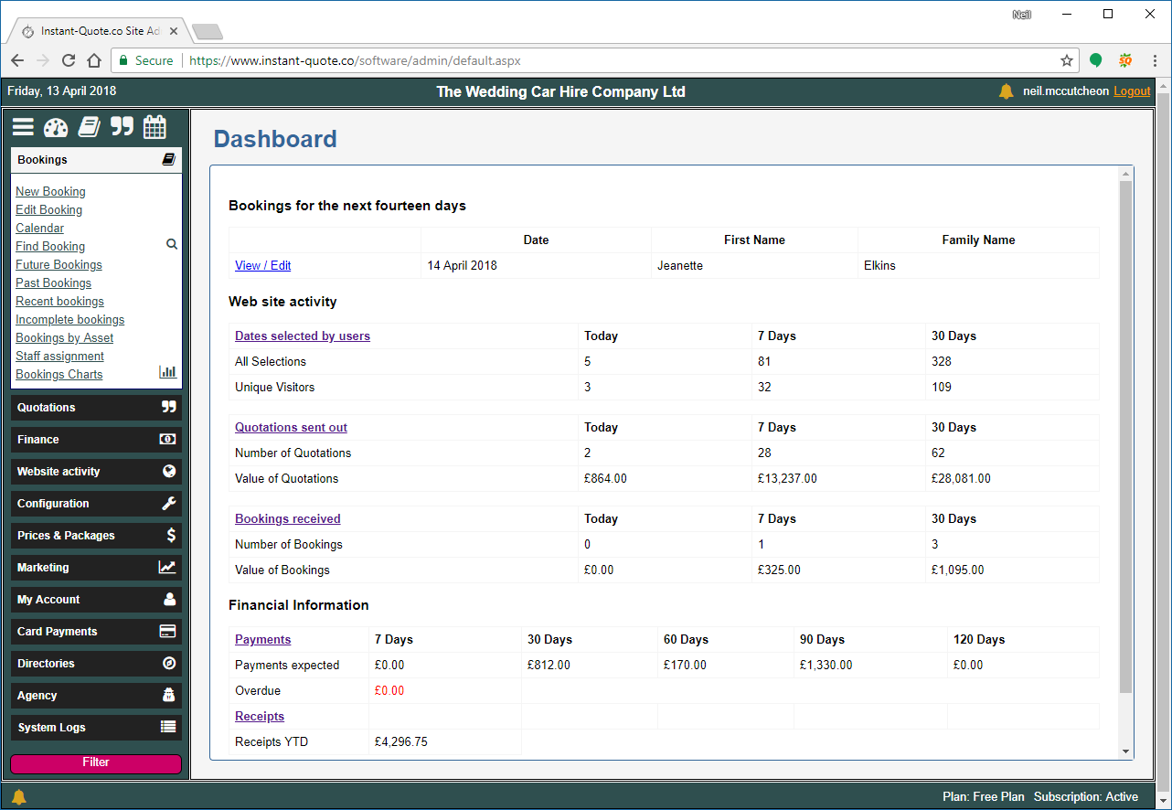
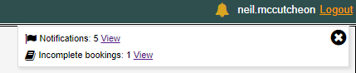
Figure 10 - The Dashboard

Figure 11- Notifications

Navigation Tab pages

Bookings Tab
Bookings contains pages for:
- New Booking
- Edit Booking
- Calendar
- Find Booking
- Future Bookings
- Past Bookings
- Recent Bookings
- Incomplete bookings
- Bookings by Asset
- Staff Assignment
- Bookings Charts

New Bookings
New bookings are created using the new booking wizard.
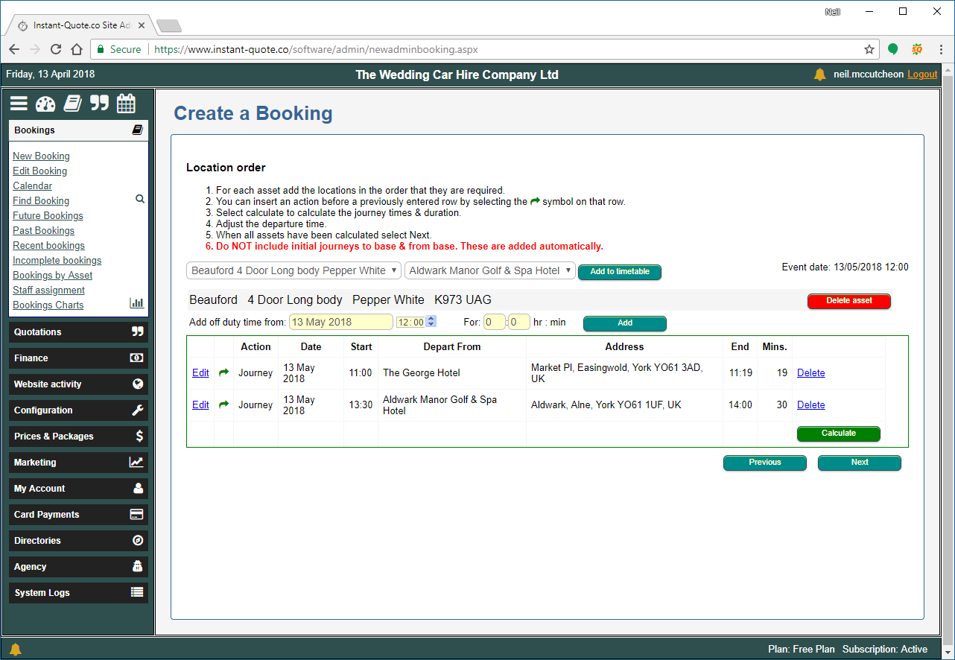
Figure 12- Adding journeys to a new booking
If the customer has had a quote, we can prepopulate the form with some details.
The wizard has a few steps that need to be completed:
- Event date and timings
- People
- Locations
- Extras
- Payment method
As with other parts of the system, it is integrated with Google to assist in looking up places and their addresses and to calculate the times and distances between locations.
Users can also enter details of off duty time – where there might be a break in the proceedings, and additional trips between base and the event. If these are configured, the charge for these periods is taken form the price list.
The bookings wizard calculates the price for the event. The user can examine the steps the system took to calculate the price and override it if necessary should they be offering a discount.
Once the booking is complete, a booking confirmation is sent to the customer and the event is added to your Google calendar.

Editing bookings
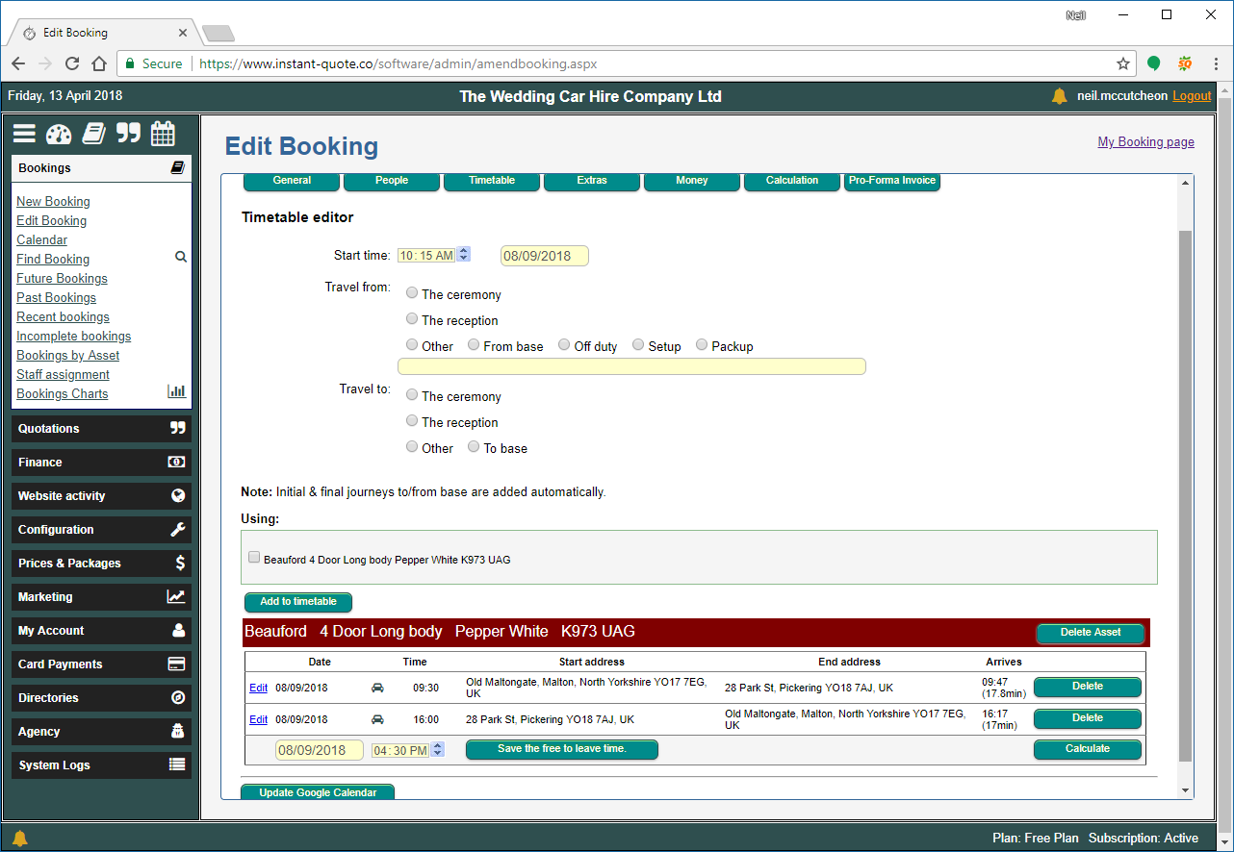
Figure 13 - Editing the booking timetable
Every aspect of a booking can be edited and the Edit Booking page has seven tabs:
- General
  - See and adjust the date of the event, amend locations, add staff to a booking and store notes – both visible to the customer and private notes.
  - Send the timetable for the event to staff.
- People
  - View and edit the details of the customer and their contact details.
- Timetable
  - Add items to the booking and adjust the timings of the day.
- Extras
  - Add and edit extras included in the booking.
- Money
  - Take card payments (automatically assigned to the customer’s account) or add details of bank transfers.
  - Assign your costs to the booking which appear in your financial statement.
  - Adjust the price of the booking.
  - Send a receipt / statement of account by email.
- Calculation
  - View how the system reached the price for the booking,
- Pro-Forma invoice
  - View an editable pro-forma invoice for the booking

Other pages under bookings
Future, Past, Recent and Incomplete bookings
These are lists of bookings arranged according to their page title.
A colour coded system is used to tell you something about the booking at a glance. In particular Syndicated bookings have a Gold background, Incomplete bookings have purple text and deleted bookings have a line through the text.
Additionally, the future bookings page displays icons to indicate:
- Whether the customer has paid in full.
- Whether you have assigned staff to the booking.
- Whether the customer has received a courtesy call just before the event to confirm timings etc.
- A link to your email application with the customers email address.
Bookings by Asset
This page enables you to view how an item has performed in terms of bookings in the past and into the future. This is an essential page for when you are looking to invest in new product.

Staff assignment
Here you can see the work you have assigned to staff both in the past and in the future.
The calendar presents all of your bookings from the previous 12 months and your future bookings.
Bookings can be seen by month, day, week or year. Alternatively, they can be presented by asset or on a timeline.
Items display their departure time and the time they return to base.
Selecting an item displays a pop-up containing the booking details and a link to the edit booking page.

Bookings Charts
The bookings charts page gives you an instant insight as to how the business is performing with regard to the number bookings.
It provides five charts:
- Schedule of sales
- Schedule of fulfilment
- Month on month comparison at time of year.
- Most popular day to make a booking.
- Distribution of days booked.
Using these charts, you can compare the number of bookings by month for the last three years, see how many bookings you have to deliver, and see where you are in reaching previous years figures at a given point in the year.
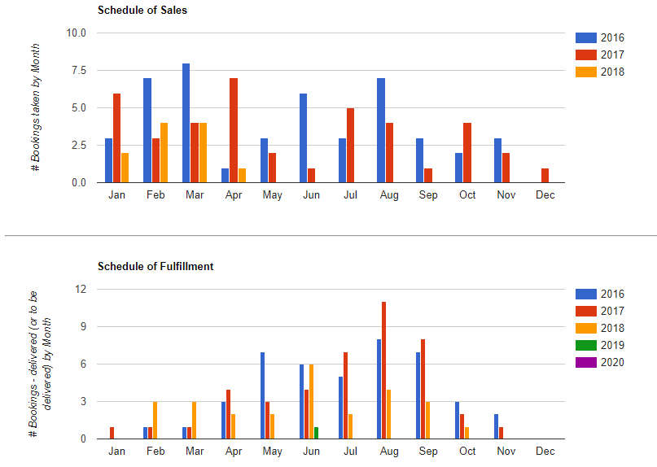
Figure 14 - Bookings charts

Quotation Tab
The quotations tab contains links to six pages:
- Create Quotation
  - Use the quotation wizard to create and issue quotes.
- Find Quotation
  - Search for Quotations
- Quotation History
  - View all of your quotations
  - View a list of quotations obtained by a customer
  - Add notes.
  - Prevent the follow-up email from being sent.
- Quotation values by month
  - View a table of quotation values that can be sorted by month and year
- Quotation Charts
  - See charts comparing the source volume of quotes sent out by month, the source of those quotations, when people get quotes and the day they get a quote for.
- # Quotes by Asset
  - See the number of quotes sent out for a given item over a period of time.
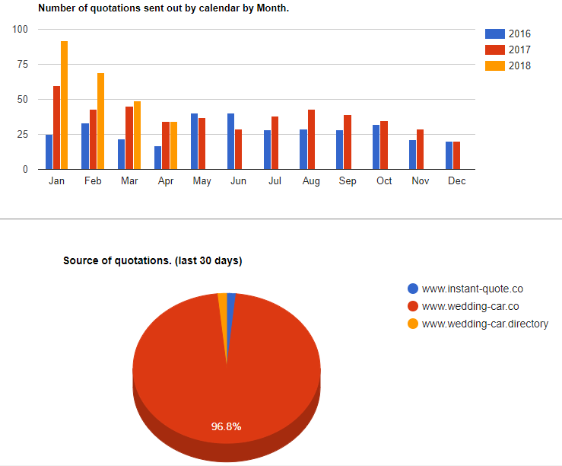
Figure 15 - Quotation Charts

Finance Tab
The finance tab is the Engine Room of your business. It features key financial information about your business that is either generated by the system or supplemented by your own system housekeeping.
The tab contains 8 pages:
- Payment Schedule
- Sales
- Receipts
- Expenditure
- Financial statement
- Expenditure Categories
- Sales Commission
- Configure Sales Commission

Payment Schedule
The payment schedule lists all of the payments due to your business, listed in chronological order. Overdue payments are highlighted in red.

Sales
Sales provides a graph comparing the businesses sales performance over the last four years, including the current year, making it easy to make a comparison.
The page also contains a sortable table that displays sales by Year & Month along with the number of sales, the value of sales and the average sale value.

Receipts
Receipts provides a table listing all of the receipts for the business and can be configured to show any given date range.

Expenditure
The system allows you to define your own categories and subcategories of expenditure. These are setup under Expenditure Categories. These settings are similar to a nominal code in accounting.
Top level categories can be setup to suit your business and might include Serivce Delivery, Office Costs, Professional Services.
In turn, for example, Professional services might include Bank charges and Accountancy.
As you receive bills for the business, it becomes a simple matter of recording your expenditure in the form provided.

Financial Statement
The data from your expenditure along with the sales and receipts go to making up the Financial statement.
Data is displayed as a table and the date range is selectable.
Where there are charges against a transaction such as when a customer pays by card, these are displayed as a debit, but to ease reconciliation of a bank statement, the gross and net receipt are listed.
The financial statement can be downloaded in .csv format for import into other software.

Sales Commission
The system supports staff earning sales commission on bookings.
The commission rate is configurable for each of your authorised users with a percentage commission assignable for a date range.
The commission is assigned to the user that is logged in when the booking is processed.
The Sales Commission page lists the commission earned by each user by month.

Website Activity Tab
This tab has five pages that relate to website visitors and statistics.
The pages are:
- Dates Selected
- Selected Dates Charts
- Visitor Location Map
- Conversion statistics
- Weekly Statistics

Dates Selected
Each time a visitor selects a date on the quotation page, the system stores the selected date, the user’s IP address, the day of the week selected, the number of weeks to the date selected and the person’s estimated location – based on their IP address.
This information is presented on a table.
Records for a given IP address can be deleted should you desire.

Selected Dates Charts
The data collected from the Dates Selected (above) is presented as a graph showing selected dates by month and a Pie Chart of the showing the Selected dates by popularity.

Visitor Location map
The Visitor location page also takes the Dates Selected data and presents it in a map to illustrate the likely locations of your website visitors.
The map can display the location of visitors for the last 30, 60, 90 and 120 days.

Conversion Statistics
This page allows you to gain two key insights into your website visitors:
- The number of months between the quote date and the event date.
- Your conversion rate of quotes to bookings.
You may wish to take these values into account when fine tuning your prices and your marketing activities.

Weekly Statistics
Weekly statistics presents tables of data for either of the last two years and the current year so you can make a comparison of the businesses’ metrics by week number.
The table includes:
- Week number.
- Unique website visitors.
- The count of the dates selected by the unique visitors.
- The number of unique visitors getting a quotation.
- The number of bookings received.
- The value of the bookings received.
- The amount of money collected.

Configuration Tab
The configuration tab contains most of the pages that need a user’s attention to get the system working how they want it.
It’s an extensive collection of settings but doesn’t contain anything a business owner wouldn’t know about their business.
The work flow for system Configuration is to:
- Configure the host settings
- Setup your pricing model
- Add your items (assets)
- Add a price list for each of your assets on each of your hosts
- Check your settings by using the Settings Playground
- Add the quotation page to your site (contact support for assistance)
- Add the quotation Facebook application to your Facebook page
- Adjust the Quotation page to your requirements.
- Edit the Document templates to suit your needs
- Add descriptive text about your business
- Add SEO locations
- Test the quotation page.
For an average business, setup should take no more than two to four hours – depending on how many items you have to promote, but once it’s done, it’s done.
Not every feature is ‘compulsory’ but they generally make your life easier in the long run. For example, there is no need to add staff, but if you do, you can assign a booking to them, email the job sheet to them and give them access to the staff portal to access information without logging in.
Staff gain access to the portal using their email address and a PIN code you have assigned at:
https://www.instant-quote.co/jobs.aspx
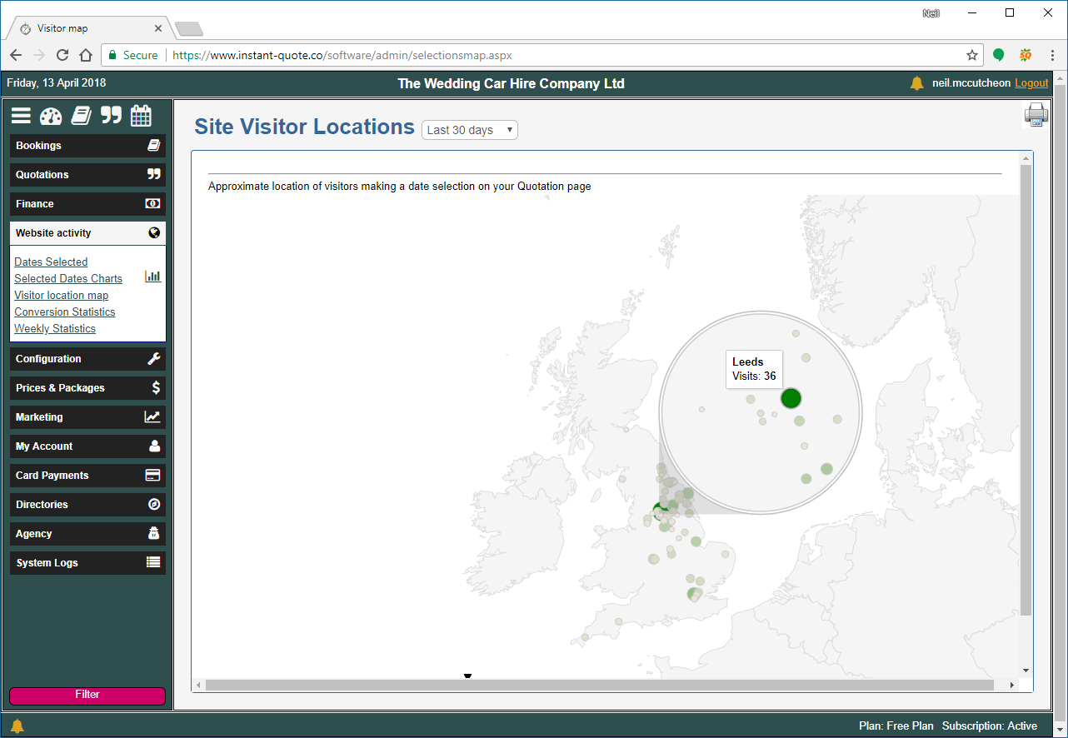
Figure 16 - Website visitor Locations

Google Calendar Integration
Under configuration, there is a Google Calendar Authorisation page.
By Authorising the system to access your calendar, we can publish your bookings to it.
On its own this is not amazing, but it does have benefits.
When we publish the event, we publish the time to leave base, the time you will return, the first destination in the booking, the time you should be there and a link to the customer’s ‘my booking page’.
This means all of that information is now on your smart phone and there is no need to take paperwork with you.
When you leave for the event, simply click on the location of the event in the Calendar and Google maps navigation will load – configured to guide you to the event.
With access to the my-booking page any other addresses are also to hand.
The entry in the calendar is updated if the event is cancelled or the duration changed.
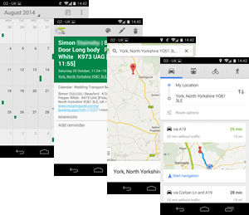
Figure 17- Launching navigation from Google maps on a mobile phone

Prices and Packages tab
The prices and Packages tab contains all of the configuration pages for individual pricing of your items.
You can configure low, medium and high seasons, set up premium days, group your items into packages of assets and bundle extras.
If you charge tax, such as VAT, you can configure that here too.

Settings playground
The setting playground is a useful tool to verify your settings.
The page is connected to the pricing engine and allows you to test your pricing model with any of your items for a given date.
Once you enter the profile of a booking and select Calculate, the system displays the calculated price for the booking based on the parameters entered. It also displays a written description as to how it reached the price.
You can change the business model to see what impact it has on price to fine tune your pricing policy.

Marketing Tab
The marketing tab has the following pages & functions:
- Manage Invitations to Review
  - Prevent review invitations being sent
- Manage Customer reviews
  - View and respond to customer reviews
- Follow-up / Voucher Emails
  - Define when emails are sent following up a quotation
- Quotation Contact Info.
  - See and download contacts who have had a quote in a date range
- Download all Contacts
  - View and download all contacts for future events
- Your Email Server
  - Configure the system to use your own email server

My Account Tab
The My Account tab has the following pages and & functions
- Billing
  - Historical and current billing data for your account.
- Subscription Invoices
  - The payment status of your account
- Price List
  - What we will bill you for
- Billing plan / Card details
  - For storing your payment card details and selecting your subscription
- Change Password
  - Change password form
- User Site Access report
  - List of pages denied to a user
- Company Details
  - Your company contact details.
Note: We do NOT store payment card details, in fact we never see them. The card details are exchanged with our card processor for a token representing the card over an encrypted connection.

The Card Payments Tab
The card payments tab has three pages as follows:
- Accept Credit Cards
  - Connect your account to our card processing partner and start taking payments with the system.
- Card Processing Fees
  - Configure a card handling fee. (Now illegal in Europe).
- Quick Card Payment
  - Process a card payment that’s not related to a booking.

Directories Tab
The system provides a quotation page that includes every item on the system. This is intended for use by directories such as the Wedding Car Directory (www.wedding-car.directory).
The quotation page on the directory displays items closest to the event location at the top of the list, providing a level playing field to every customer. As with the standard quote page, it only displays items that are in range of the event.
The wedding car directory not only hosts a central source of wedding cars but also provides a small web site for each supplier listing each of the items they offer. Additionally, each item has its own page with advanced page mark-up to assist search engines, and each business has its own quotation page. Furthermore, any reviews for an item are also listed.
When a customer searches for a review of your product on Google, it is generally the car’s individual page that is found.
Try the following searches in Google as examples:
- Beauford wedding car review York
- Beauford wedding car review Leeds
Currently these appear on page 1 near the top and stand out because of the Star rating,

Making the most of Directories
To make the most of your directory entry:
- Ensure you have put accurate informative text in the description for your items.
- Complete the Company Description in the Directories / Directory text page.
- Load the default Locations under Directories / SEO locations.
- Add specific Venues you want to associated with using the Custom Places form on the SEO Locations page.

Agency Tab
The Agency Tab is out of the scope of this document except to say this is where Agency bookings are passed between the Agent and the Supplier and the payments record is maintained.
Should you wish to share items with other suppliers, please request the latest documentation.

System Logs Tab
The system logs tab contains pages for notifications and email errors.
You will receive notifications for a range of system events including payments, new bookings, subscription status changes, activity of an agent regarding payment on one of your bookings.
Advice that you have notifications appears as a golden Bell at the top and bottom of your administration page.

Online Booking
The system supports online booking and a link can be placed in the Quotation template. In our experience, less than 1% of customers use the online facility to make a booking.
In common with the administration’s New Booking page, the online booking form prepopulates the form with information where possible.
Customers enter, the date, the people involved, the items they want to book and the locations and timings. They select any extras they require and then the system calculates the cost of the booking.
If they are happy with the cost, they can book.
The customer is then redirected to their My Booking page where they can pay their deposit by card.

Abandoned bookings
If the customer fails to complete the booking, or runs into difficulties making the booking, you will find their data in the Incomplete bookings page. You can then complete the booking on their behalf.

System Pricing
Instant-quote.co provides a level of business advantage that should not be ignored. It makes running the business more effective, saves time, provides better customer service, backs up your business data and increases the exposure of the business on the Internet.
As pricing is based on system load, it means the little guy pays nothing or very little and bigger businesses pay more as they consume more resources, but, whatever the size, the system provides outstanding value for money.
The system pricing is similar to a mobile phone plan; you pay a subscription and get a bundle of services in the price. Unlike a mobile phone plan, our prices start at free.
The current subscriptions are:

Agency Pays

Limitations
- You are not permitted to use the quotation page on your website or the Facebook application.

Monthly Costs
No charge – The agency pays your fees.

Free Plan

Limitations
None

Includes
- Assets 2
- Free Quotes 10
- Web hosts 2

Monthly Costs
- Additional Assets / packages £7.00
- Additional Web Hosts £2.00
- Additional Quotes £0.50
- Subscription £0.00

Low Plan

Limitations
None

Includes
- Assets 4
- Free Quotes 50
- Web hosts 2

Monthly Costs
- Additional Assets / packages £3.00
- Additional Web Hosts £2.00
- Additional Quotes £0.50
- Subscription £15.00

Medium Plan

Limitations
None

Includes
- Assets 6
- Free Quotes 100
- Web hosts 4

Monthly Costs
- Additional Assets / packages £2.00
- Additional Web Hosts £2.00
- Additional Quotes £0.50
- Subscription £20.00

Professional Plan

Limitations
None

Includes
- Assets 10
- Free Quotes 150
- Web hosts 8

Monthly Costs
- Additional Assets / packages £2.00
- Additional Web Hosts £2.00
- Additional Quotes £0.50
- Subscription £25.00

Professional Plus Plan

Limitations
None

Includes
- Assets 30
- Free Quotes 300
- Web hosts 12

Monthly Costs
- Additional Assets / packages £2.00
- Additional Web Hosts £2.00
- Additional Quotes £0.50
- Subscription £30.00

Directory Only

Limitations
- Maximum of 3 quotes per item over the last 30 days from any Quotation page.
- Cannot share / syndicate assets

Includes
- Fair usage

Monthly Costs
- Subscription £0.00

Agency Plans
Agency plans are bespoke plans that depend on the usage of the system.

Quotations & billing
For billing, the billing count of Quotations sent out is not simply the sum of quotes. If a site visitor selects a date for a quotation and gets a quote, that counts as one quote. Any further quotations obtained on that day that are for the same date still count as one quote, so a user repeatedly selecting the Get Quote button does not inflate your quotation count.

